Year 5 Spring Homework Menu
Spellings  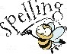  The year 5 and 6 spellings are found on the Year 5 class page. Please encourage them to practise these weekly. | Reading  We would still love you to be reading as much as possible at home and have this recorded on Boom Read. Every Friday, we’ll check who is a ‘Fab Four Reader’ (read 4 x a week at home), and you will get a sticker and a Candleby Credit! | Reading  Enjoying the book that you are reading at home or in school? Can you write a summary for a book you are enjoying reading at the moment?  What is the book about? Why do you enjoy this book so much? What are the key ideas from the text you have read? | Writing – poetry  We’ll be learning all about writing a narrative in English. Write a narrative based on an adventure that children go on.  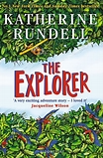
Art  In art, we are studying the Henri Rousseau and his artwork. Draw/paint a picture in the style of Henri Rousseau.  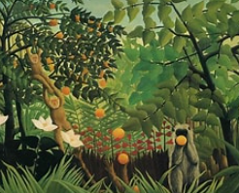 | Maths – times tables  This half term, we’ll be continuing to learn the rules of our times tables.  To become a true times table Rockstar, can you use times table rockstars every day for 15 minutes?   | Science – Living things and their habitats  In science, we will be looking at the life cycles of different animals. Can you represent the life-cycle of an animal of your choice?  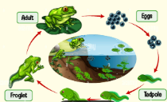 | RE  This half term we will be learning about ‘Believing’ by learning about key religious figures like Dr Martin Luther King and Mother Teresa? Research a religious leader from the past of the present.
Writing  Create a free-verse poem about a subject of your choosing.  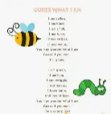 | Geography  In geography we are learning about South America. Create a map of South America.  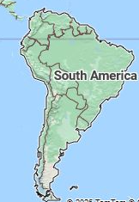 | HBHM  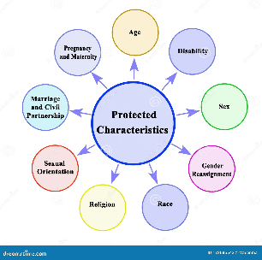  In HBHM, we will be learning about protected characteristics. Create a poster on the different characteristics. | Geography  We are also researching the rainforest (particularly deforestation). Produce a fact file on the rainforest.  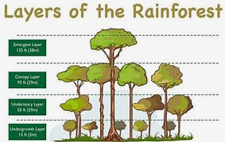
Our driver for this term is Geography and our enquiry question is: How do Geographers become Earth detectives. We’ve created a menu of homework for the children with 12 homework options to choose from. Your child will receive a ‘star on the door’ for the first piece of homework they complete and 2 Candleby Credits for each piece after that! Each week, we will celebrate all homework that the children bring in. Please feel free to email us photographs of the children completing their homework too – we love to see them!

