Year 6 Autumn Homework Menu
Spellings  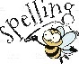  The year 5 and 6 spellings are found on the Year 6 class page. Please encourage them to practise these weekly. | Reading – Boom Read  We would still love you to be reading as much as possible at home and have this recorded on Boom read. Try to read 4 x a week at home and you will be rewarded a Candleby Credit! | Reading  Enjoying the book that you are reading at home or in school? Can you write a summary for a book you are enjoying reading at the moment?  What is the book about? Why do you enjoy this book so much? What are the key ideas from the text you have read? | Writing – Flashback  We’ll be learning all about writing a flashback in English. Could you write a flashback inspired by your summer holiday. You could even create a comic strip.
Art  In art, we are studying the artist Henry Moore and his artwork. He focused on perspective. Could you a find an example of his artwork and replicate it.  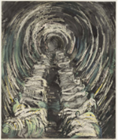 | Maths – times tables  This half term, we will be focusing on place to 10 million, consolidating our knowledge of the four number operations (addition, subtraction, multiplication and division) and fractions.  Please continue to practise your multiplication tables at home. | Science – materials  In science, we will be looking at light and electricity.  Can you investigate how we see objects through our eyes.  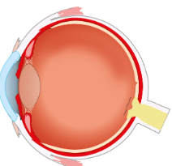 | RE  This half term we will be learning about religious communities around the world.  Can you think of any religious communities in our local community? What symbols are used to show these religions?
Design and Technology  In D and T, we will be building up to designing and creating your own Anderson shelter. To enhance this, could you create your own shelter out of recyclable materials?  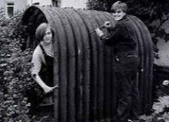 | History  In history, we are going to immerse ourselves with World War 2. Could you create your own fact file on Winston Churchill or Adolf Hitler? | HBHM  In HBHM, we will be learning about family relationships and friendships.  Design a poster that promotes what a “Good friend” looks like.
Our driver for this term is History and our enquiry question is: What if a voice isn’t heard? We’ve created a menu of homework for the children with 12 homework options to choose from. Your child will receive a ‘star on the door’ for the first piece of homework they complete and 2 Candleby Credits for each piece after that! Each week, we will celebrate all homework that the children bring in. Please feel free to email us photographs of the children completing their homework too – we love to see them!

