Year 5 Autumn Homework Menu
Spellings  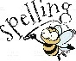  The year 5 and 6 spellings are found on the Year 5 class page. Please encourage them to practise these weekly. | Reading  We would still love you to be reading as much as possible at home and have this recorded on Boom Read. Every Friday, we’ll check who is a ‘Fab Four Reader’ (read 4 x a week at home), and you will get a sticker and a Candleby Credit! | Reading  Enjoying the book that you are reading at home or in school? Can you write a summary for a book you are enjoying reading at the moment?  What is the book about? Why do you enjoy this book so much? What are the key ideas from the text you have read? | Writing – poetry  We’ll be learning all about writing a Poem in English. Could you write a Poem inspired by our Anglo-Saxon/Viking enquiry? Could you describe what it was like to live as part of an Anglo-Saxon village?
Art  In art, we are studying the artist David Hockney and his artwork. Draw/paint a self-portrait in the style of David Hockney.  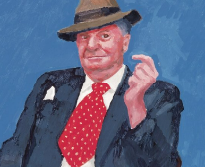 | Maths – times tables  This half term, we’ll be continuing to learn the rules of our times tables.  To become a true times table Rockstar, can you use times table rockstars every day for 15 minutes?  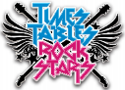 | Science – materials  In science, we will be looking at materials and their properties. Could you find materials outside of school that represent the different properties? Take pictures of what you’ve found. | RE  This half term we will be learning about religious buildings. Could you create a model of the buildings that are sacred to the main religions around the world?
Design and Technology  In D and T, we will be building up to designing and creating your own Viking Longship. To enhance this, could you create your own longhouse out of recyclable materials?  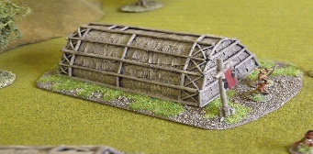 | History  In history, we are going to immerse ourselves with the Anglo Saxons and the Vikings. Could you create your own shield or weapon that may have been used during these times?  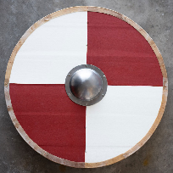 | HBHM  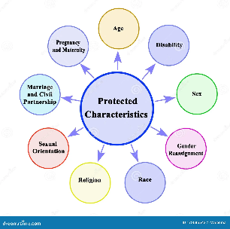  In HBHM, we will be learning about protected characteristics. Create a poster on the different characteristics. | History  We will also be looking at how the Vikings used runes to communicate. Research what they mean and bring in your own secret message to share with the class!  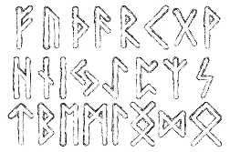
Our driver for this term is History and our enquiry question is: What if conflict never happened? We’ve created a menu of homework for the children with 12 homework options to choose from. Your child will receive a ‘star on the door’ for the first piece of homework they complete and 2 Candleby Credits for each piece after that! Each week, we will celebrate all homework that the children bring in. Please feel free to email us photographs of the children completing their homework too – we love to see them!

